

CMPSC 460 (Spring 2026)
Princ Prog Lang

SLR Research article

Aram Asdourian
Matthew Wybranski

Instructor: Gina Mejia-Madrid

Submitted On: 4/20/2026

Table Of Contents
# | Section | Page
1 | Abstract | 3
2 | Introduction | 3
3 | Theoretical Framework (SLR) | 3
4 | Methodology | 5
5 | Results | 6
6 | Conclusions | 11
7 | Acknowledgments | 11
8 | References | 12

Abstract
In this paper we conduct a SLR research on how the modern structure and operations of modern tech companies are shifting to give employees more access to work-at-home opportunities and are starting to embrace the assistance of AI in software development and project management. Using these findings we construct a fictional company, named M&A, and create a organizational structure with 7 departments; administrative, artificial intelligence, general software development, racket software development, quality assurance, sales & marketing, and research & development. These departments make use of 3 artificial intelligence agents developed by the artificial intelligence department; M&A structuring assistant, M&A DSL racket agent, and the M&A Customer support agent.

Introduction
Due to the rapid advancement of modern technology, many modern software development companies are changing their approach to development so they can adapt to these advancements. This rapid advancement is creating a divide in what software companies look like in the modern age compared to in previous years. This Systematic Literature Revie (SLR) aims to research what has changed about modern software companies due to new technologies. A fictional company will be constructed from these findings.

Theoretical Framework (SLR)
# | Author/Year | Context | Key Findings | Contribution to My Company | Link
1 | Smite, et al. (2024) | Work from home in software companies | A Variegated team structure sets predetermined work-from-home days which enhance team cohesion and lets developers work in their preferred environment | Employees are allowed to work from home on predetermined days but must come in for a set number of days to encourage greater team cohesion | SWSI_2022_09_0107.R2_Tell_author.pdf
2 | Biazzo & Filippini (2021) | Analyzes various development team structures | The 4 development team structures functional, lightweight, heavyweight, autonomous, are all useful strategies to tackle increasingly complex projects. | Dynamically use the 4 team structures based off complexity of a project | Organizing Development Projects: Structural Choices and Planning Approaches | Springer Nature Link
3 | Kota, et al. (2025) | Effects of AI usage in software development | AI use increased productivity, enhances collaboration, and accelerated QA. But it also has the ability to displace entry-level jobs and disrupt existing workflows. | Integration of AI into the company must take a cautious, balanced approach. | Effects of AI on Software Development | Semantic Scholar
4 | Alenezi, M., & Akour, M. (2025) | AI-Driven Innovations in Software Engineering: A Review of Current Practices and Future Directions | AI is fundamentally reshaping how software is developed and the process that is used to develop it. There is also a synergy that can be found in AI-driven analytics and software development teams. | AI can help drive the process of software development, and employees should be encouraged to work with AI as a synergistic tool. | https://www.mdpi.com/2076-3417/15/3/1344
5 | Bhumeka Narra, et al. (2024) | The Integration of Artificial Intelligence in Software Development: Trends,  Tools, and Future Prospects | AI tools can streamline many monotonous activities and improve code quality and user experience. However, lack of transparency and security issues pose challenges when using said tools. | AI tools can be great when debugging software as it may catch an issue that the programmer may not see. | Link

Methodology

SLR
The methodology for creating our SLR table was to research articles from the past 5 years relating to how the structure and operations of modern tech companies are shifting due to recent advances in technologies (including but not limited to Artificial Intelligence). We found these articles by using the AI powered article research tool ‘elicit’ which guided us to do further research on these 5 articles that we included in the SLR. The subject matter of these articles mostly related to how AI impacted modern tech companies (Kota, et al. Alenzi & Akour. Bhumeka, et al.). One touched on how the impact of covid led to may companies embracing the work-at-home culture (Smite, et al). And the final article analyzed 4 key structures for internal developmental teams that are commonly used in modern software development (Biazzo & Filippini).

Company
The methodology for creating our company was to first lay a foundation and then grow from there by analyzing our SLR findings. First we decided to construct a general purpose software company that does contract work with clients. From there we analyzed our SLR findings and found a massive shift towards the use of AI in modern software companies. So to further the construction of our company we included 3 AI agents to assist in our companies activities. One of these is a structuring agent that takes insights from our SLR regarding development team structures.

Results

Corporate identity
- Company name: M&A
- Mission: To provide the best software for our clients
- Vision: To work with numerous clients on creating the software they need
- Products & services we provide: Contract software development for our clients
- The problems we solve: Help clients bring their software vision to life

Company Model
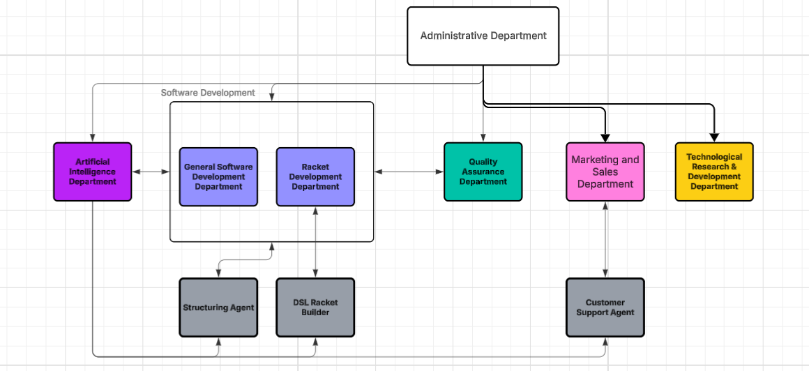

Departments

Administrative Department
The administrative department oversees every other department. They make critical decisions and executively manage the timeline of projects. They hold the power to make executive management decisions based on the internal structure of each department (hiring, firing, transferring employees between departments, etc.). They also determine the allocation of funding to each department.

Artificial Intelligence Department
The artificial intelligence department develops and maintains the artificial intelligence agents used by the company. The agents are provided to the software development departments to assist with bug testing, idea crafting, guidance with projects, etc. The artificial intelligence department is also tasked with taking feedback from the users of the agents and updating the agents to provide the best possible experience to its users.

General Software Development Department
The general software development department is tasked with developing the software provided by the company in non-racket languages (Python, Java, C++, etc.). When a new project is taken on, an appropriate number of members in this department are chosen based off relevant skill to form a new internal development team to work on this project from start to finish.

Racket Development Department
The Racket Development Department develops projects provided by the company in Racket. They operate in the same manner as the general software development department except exclusively work with racket and are also tasked with creating DSL’s

Quality Assurance Department
The Quality Assurance Department takes the projects developed by the software development departments and ensures there are no leftover bugs from development. They also test the program to ensure that it can easily be used by the client without any confusion or trouble. They can either return the product to software development if outstanding problems are found or approve the final product for delivery to the client.

Marketing and Sales Department
The marketing and sales department is responsible for advertising the company to potential clients. They must observe current trends and determine the most efficient method of placing advertising in both a cost-effective but wide-reaching manner. They also manage the sale of services to clients.

Technological Research & Development Department
The Technological Research & Development department is tasked with developing new and innovative technologies to be used by the rest of the company to provide an advantage over competitors.

Three AI agents

company structuring assistant

https://m365.cloud.microsoft/chat/?titleId=T_cd148716-fb06-e55b-6539-420659b110f1&source=embedded-builder
- Name: M&A Structuring assistant
- Purpose: helps structure internal development teams and company structures
- Department where it belongs: administrative and software development
- Main responsibilities: helps structure internal development teams based off project description and available staff
- Example tasks: creates a development structure based off project description
- Example Prompt: “I have a project to do [x] and I have [y] team members available. Provide a team structure that can efficiently accomplish this project”
- How this agent helps: eliminates time during the planning phase of a project

DSL racket builder
https://m365.cloud.microsoft/chat/?titleId=T_813e4c14-8cbd-6ab0-2961-229736f42aab&source=embedded-builder
- Name: M&A DSL racket agent
- Purpose: assists employees in the racket development department with programming DSL’s
- Department where it belongs: Artificial Intelligence department and Racket development department
- Main responsibilities: helps employees with programming, debugging, and understanding DSL’s
- Example tasks: points out notable bugs within an employee programmed DSL. helps an employee develop the pseudo structure of a DSL. Generate a list of ideas for a DSL.
- Example prompt: “produce a list of possible attributes that would be good to implement in a DSL about movies”
- How this agent helps: it accelerates the process of planning and debugging.

Customer Support Agent
https://m365.cloud.microsoft/chat/?titleId=T_e52c4fb1-d3d1-fc4c-a704-73d5b2a09c61&source=embedded-builder \
- Name: M&A Customer Support Agent
- Purpose: gathers information about a customer and their project and regurgitates it back to our employees for them to better understand the project
- Department where it belongs: Artificial Intelligence department and Quality Assurance Department
- Main responsibilities: helps employees with understanding who a customer is and what they want from the project/product
- Example tasks: gives employees an outline of what the customer’s project is about. Can print detailed info on the customer.
- Example prompt: “produce the customer’s idea in a clear format and an outline of what that project would include”
- How this agent helps: it helps give a clearer image to our employees on what the customer wants from the project.

Racket Development Evidence:

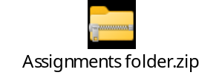

DSL:
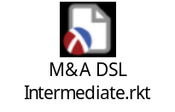LINK

Our intermediate DSL gives us a report of a project currently being worked on by our company. It provides us with detailed information on the team and the project itself. For example, the report shows how many team members a project has and how much time is left to work on the project before it's due to the client. The DSL also gives us information on the priority of the project and if it needs AI assistance using the rules we have created in it. This helps us see which projects need to be prioritized and given more funding and/or time allocation.

Company Explanation
The administrative department oversees all other department and manages deadlines, allocation of resources, assignment and taking on of projects, etc. The general software and racket development departments both develop software in collaboration with the AI department to pass their work onto the QA department. The AI department provides guidance that encourages the developer's creativity and critical thinking, while also providing efficient debugging and assistance with development. Marketing and sales manage the advertising and sale of services for the company. The R&D department develops new technologies to be used by the rest of the company to provide the company with an advantage over competitors. This structure allows each department to thrive off each other and paves the path for our company to have a prosperous future.

Conclusions
In conclusion, our 5 articles highlight the world of software development and where AI integration may be headed. This focus can be seen in each of our articles, but primarily in Smite, et al. and Alenezi, M., & Akour, M as these highlight current trends such as work-from-home days and AI software development tools in the modern landscape. While all five articles do touch on the future of their respective trends, Alenezi, M., & Akour, M. and Bhumeka Narra, et al. explain where AI could be headed in the future when it comes to its integration in software development companies such as the case with AI debugging tools. In contrast to the previously mentioned papers, Kota, et al. tackles an interesting perspective, one where companies should take caution before fully integrating AI into their work environment as there as several challenges and affects that it will have on businesses such as job displacement for entry level positions. Biazzo & Filippini talks about different team structures that will come in handy for us when developing our company model. Software development is headed towards the direction of full AI integration, and some might say we are already there, but only time will tell.

Acknowledgements
The authors of this article have no acknowledgments.

References
.Pawar, P., Kota, A., Khillare, P., & Kanchi, P. (2025). Effects of AI on Software Development. International Journal of Scientific Research in Engineering and Management.

Vaibhav Maniar , Rami Reddy Kothamaram , Dinesh Rajendran , Venkata Deepak Namburi , Vetrivelan Tamilmani , Aniruddha Arjun Singh Singh
A Comprehensive Survey on Digital Transformation and Technology Adoption Across Small and Medium Enterprises

Alenezi, M., & Akour, M. (2025). AI-Driven Innovations in Software Engineering: A Review of Current Practices and Future Directions. Applied Sciences, 15(3), 1344. https://doi.org/10.3390/app15031344

Biazzo, S., & Filippini, R. (2021). Organizing Development Projects: Structural Choices and Planning Approaches. Management for Professionals, 131–157. https://doi.org/10.1007/978-3-030-75011-4_8

Smite, D., Christensen, E. L., Tell, P., & Russo, D. (2022). The Future Workplace: Characterizing the Spectrum of Hybrid Work Arrangements for Software Teams. IEEE Software, 40(2), 1–9. https://doi.org/10.1109/ms.2022.3230289

